Java Basics II

Christian Rodríguez Bustos Object Oriented Programming

Java Basics



Agenda

Formatted output

Working with Strings

Casting

Generating Random

numbers Java Basics

Formatted Output [Deitel] Chapter 28

Printing Integers & Floating-Point Numbers Printing Strings and characters

Printing Dates and times

Java Basics



Printing Integers Numbers

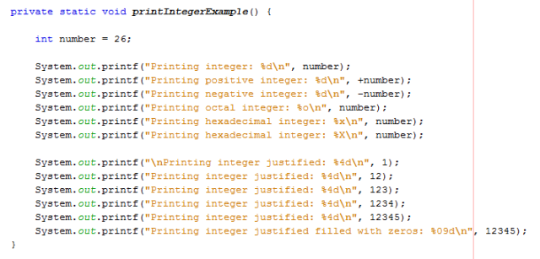

Printing Integers Numbers

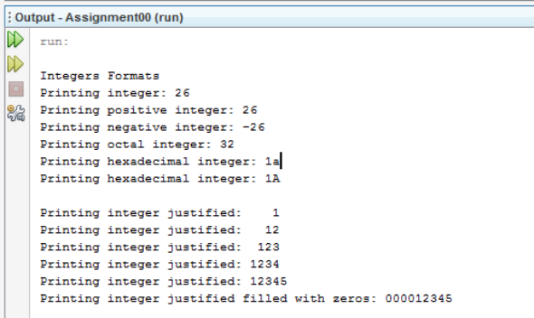

Java Basics

Printing Floating-Point Numbers





Java Basics

Printing Floating-Point Numbers





Java Basics

Printing Strings and characters





Java Basics

Printing Strings and characters





Java Basics

Printing Dates and times





Java Basics

Printing Dates and times





Java Basics

Working with Strings

[Deitel] Chapter 29

Strings Declarations

String Miscellaneous



Strings Declarations



String Miscellaneous 

Java Basics

String Miscellaneous





Java Basics

Casting

Primitive Types Casting



Value to

assign

Primitive Types Casting

Assignation variable

int long float double char byte short boolean int - A A A C C C N long C - A A C C C N float C C - A C C C N double C C C - C C C N char A A A A - C C N byte A A A A C - A N short A A A A C C - N boolean N N N N N N N -

C = Explicit Cast Required A = Automatic Cast

Casting example



Java Basics

ASCII table

Java Basics

Working with Random numbers



Generating random numbers

Remember to import the

Random Class



Generating random numbers



Generating random numbers

Java Basics

HangMan

• Write the program HangMan

– Program must choose randomly the secret word from a predefined list. (Given by me ☺)

– Program must show after each player turn the current game state:

• Which letters has been discovered. For example:

– _ b _ e _ t _ (Objects)

• How many errors has been committed until complete this figure q(x_x)p

• Which letters has been used



Java Basics

Game Output example

| System (Secret word = “object”) _ _ _ _ _ _ | Player |
| --- | --- |
|  | User try the letter a |
| _ _ _ _ _ _ q a |  |
|  | User try the letter j |
| _ _ j _ _ _ q aj |  |
|  | User try the letter w |
| _ _ j _ _ _ q( ajw |  |
|  | User try the letter n |
| _ _ j _ _ _ q(X ajnw |  |
|  | User try the letter b |
| _ b j _ _ _ q(X abjnw |  |



Java Basics

Game Output example

| System (Secret word = “object”) o b j e c _ q(X_X) abcde... | Player |
| --- | --- |
|  | User try the letter t |
| o b j e c t q(X_X) abcde... |  |
| You Win !!! |  |

| System (Secret word = “object”) o b j e c _ q(X_X) abcde... | Player |
| --- | --- |
|  | User try the letter p |
| o b j e c t q(X_X)P abcde... |  |
| You Lose !!! The secret word is: object |  |



Java Basics

References

• [Barker] J. Barker, Beginning Java Objects: From Concepts To Code, Second Edition, Apress, 2005.

• [Deitel] H.M. Deitel and P.J. Deitel, Java How to Program: Early Objects Version, Prentice Hall, 2009.



Java Basics